**Exercise 9**

**Data Visualizations**

**Milan Sherman**

1. Items per category

This is a fairly straightforward visual showing the number of items in each category. I chose this visual because it is easy to read and concisely summarizes the information.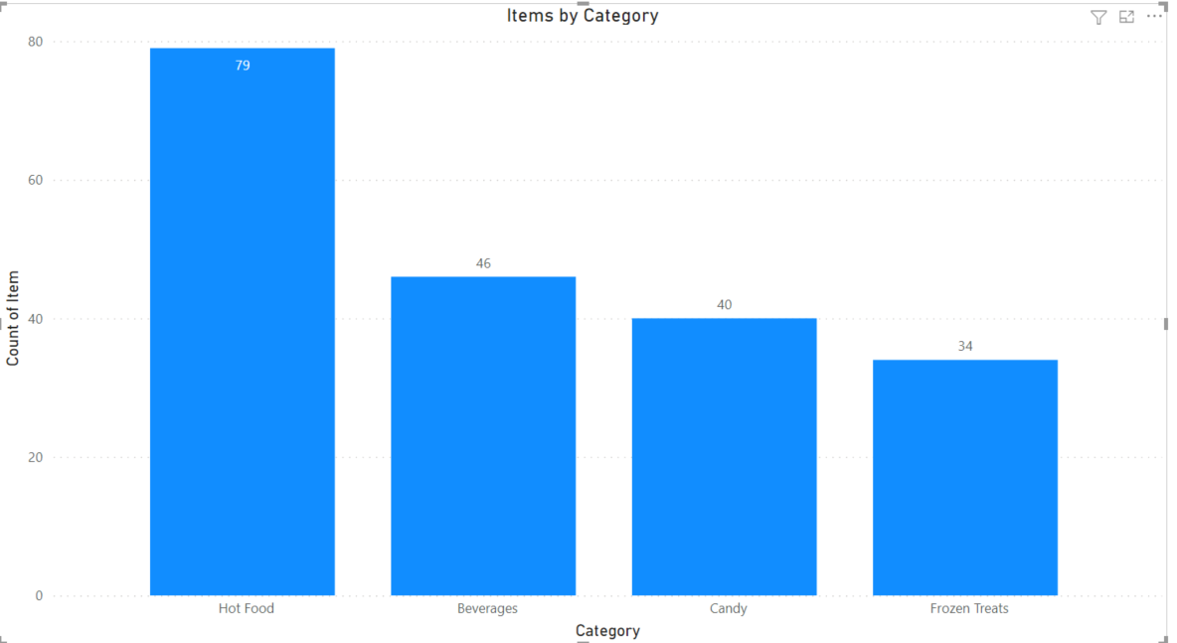

1. Profit by Item using a waterfall chart

This visual shows the amount of profit per item relative to other items in that category. I used a slicer to break it out by category, but the last screenshot shows all of the items. This allows the user to focus on a single category or look at all the items. The waterfall chart effectively displays the relative profitability of an item compared with other items, as well as the profit for each category.

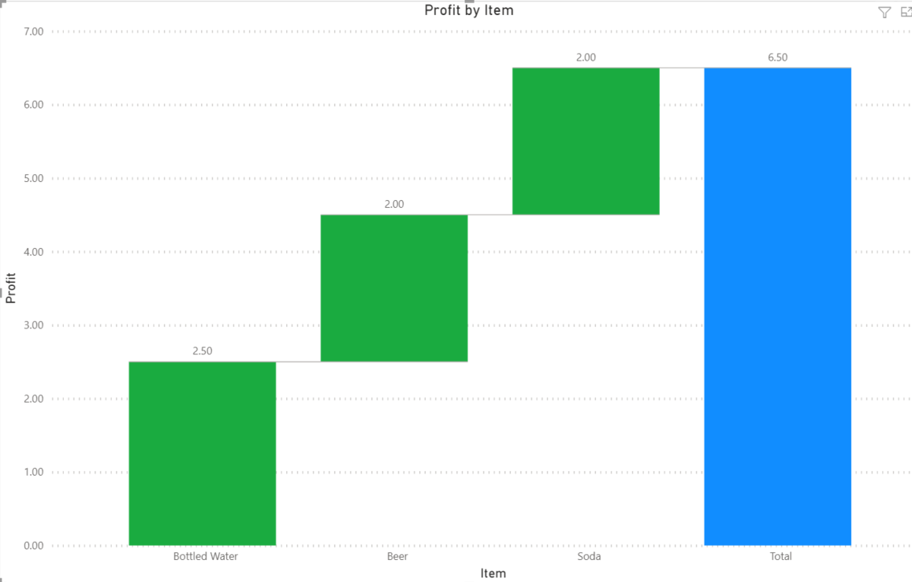

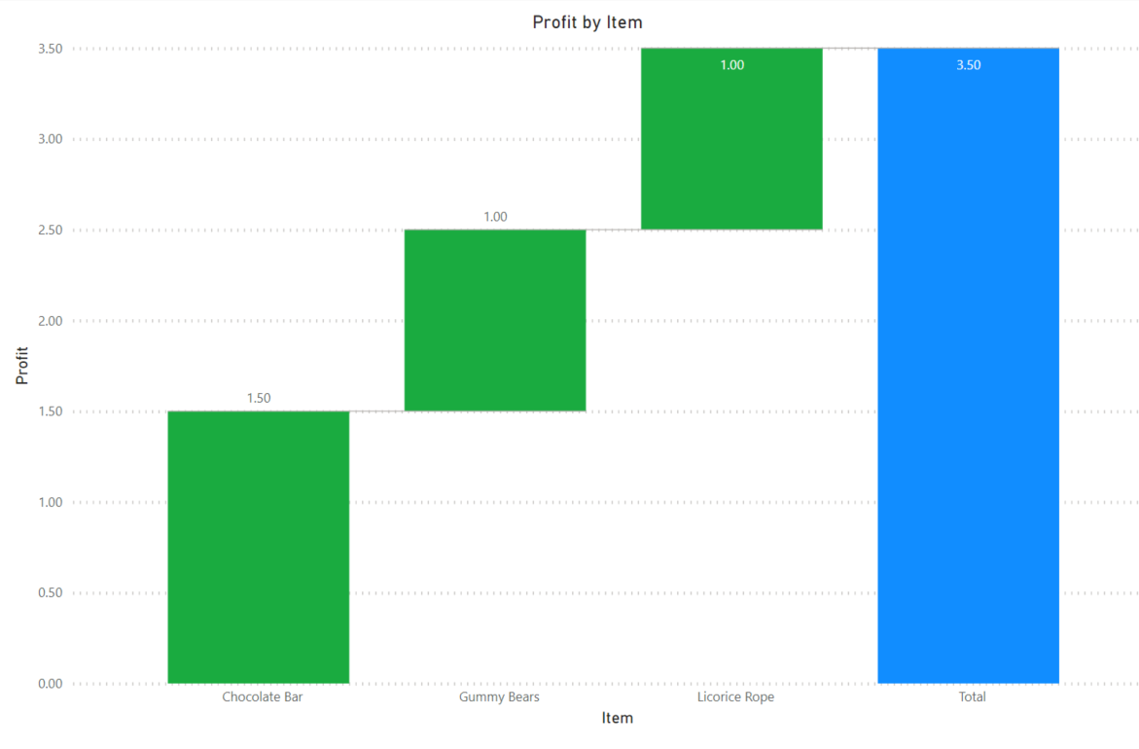

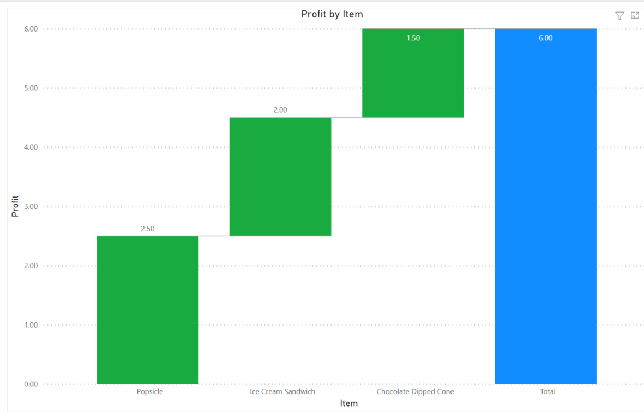

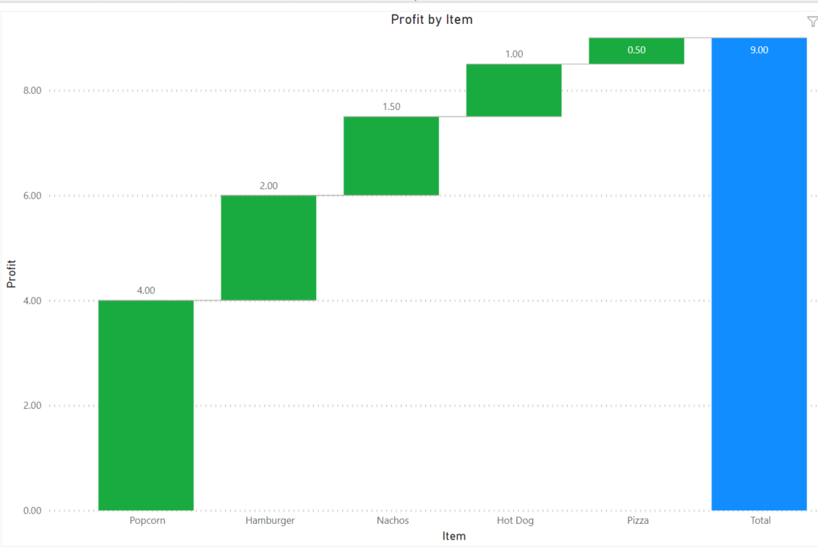

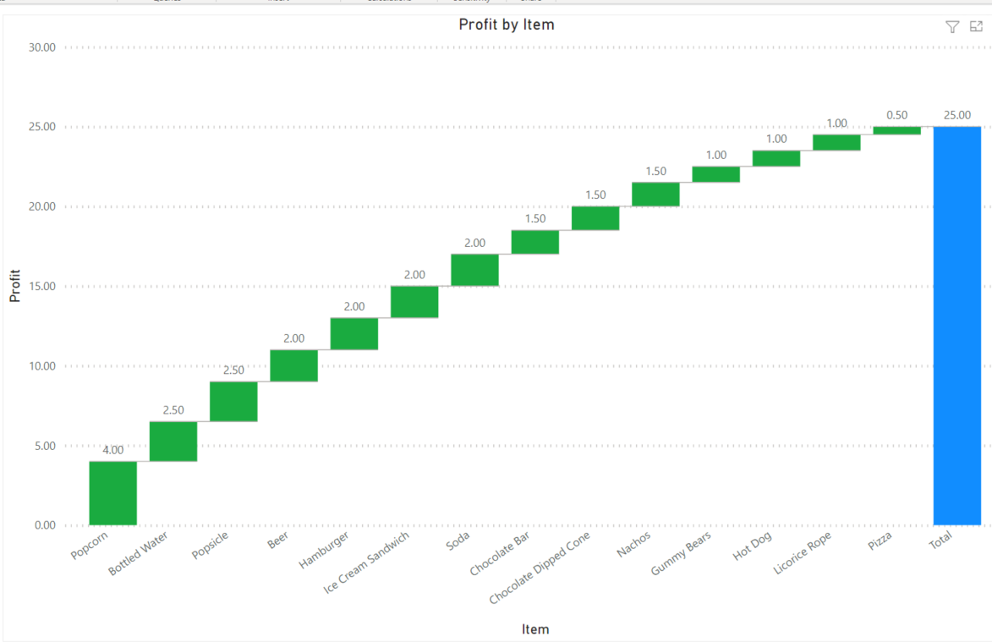

3. Trending profit chart

This trending chart sums the profit of all of the items on a given date, showing total profit for a given game. Data labels are associated with the dates of a game. This visual effectively displays how profit changed over time.

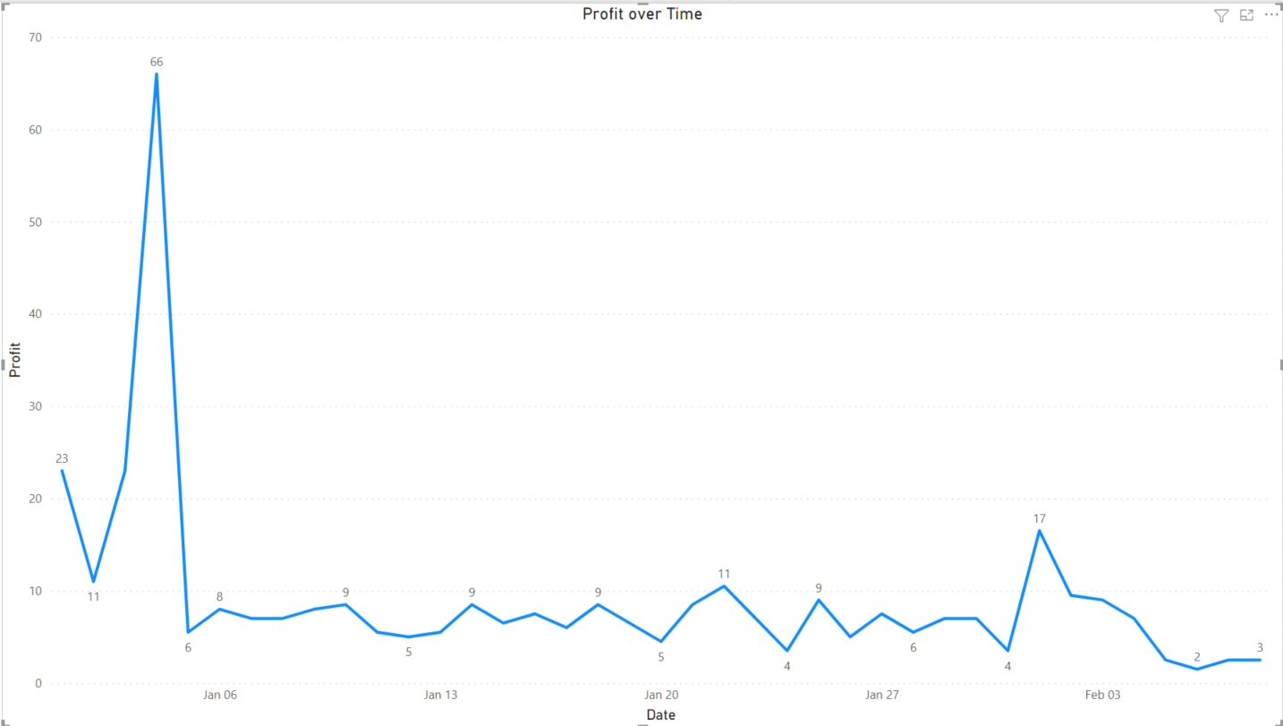

4. Calories by Item using a Donut Chart

This visual shows the number of calories for each item. The donut chart effectively shows the amount of calories relative to other items on the menu, which would be useful if someone was trying to watch their calories. For example, I find it counterintuitive that Nachos and Popcorn would actually have more calories than pizza or some of the dessert items.

